**Question 1:**

The image shows a PIM measurement in Spectrum Analyzer (SA). The scale is absolute and the requirement for the DUT to pass quality control is that IM3 level should be lower than -153dBc.

a. Is marker M1 pointing to the correct IM3 frequency? (If not, calculate the right frequency)

b. What parameters of SA can be tweaked to reduce the noise floor and confirm that IM3 level complies with the requirement?

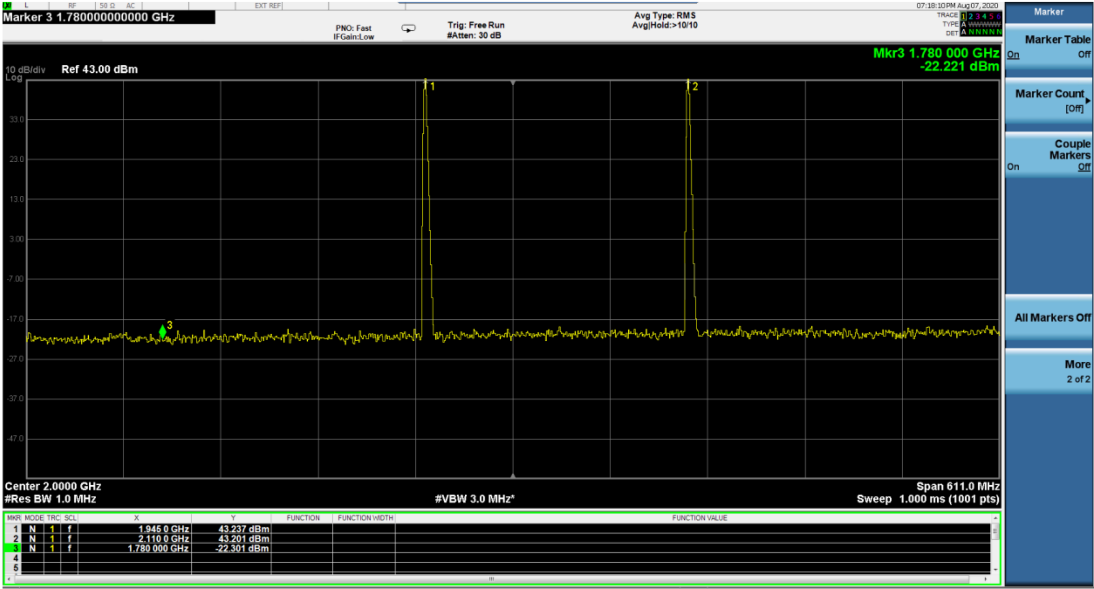

**Question 2:**

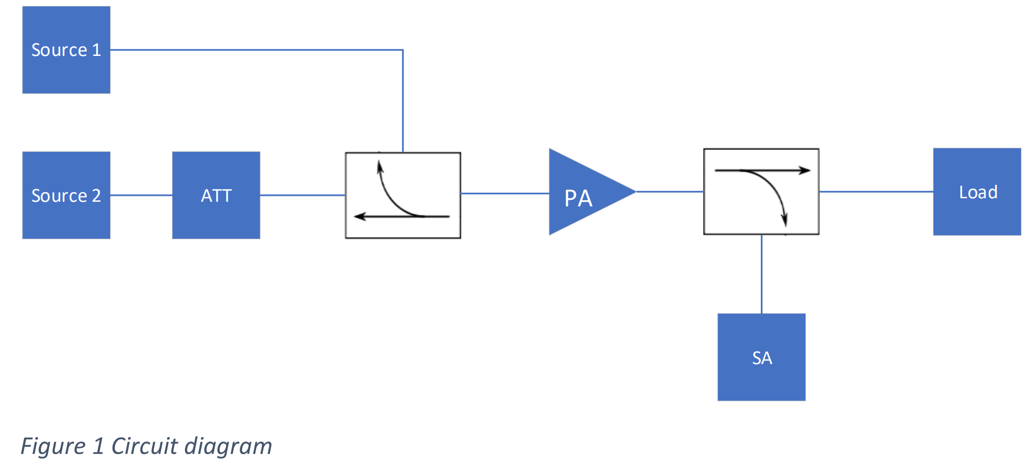

1. Using diagram shown in Figure 1, calculate amplitude of signal carriers displayed on SA.

2. Are the 3rd order intermodulation products expected under given conditions? Justify your answer.

3. Make a rough sketch of the frequency spectrum in the range of 1.7 GHz – 1.95 GHz that can be seen on the spectrum analyzer (SA). Show different signals only.

Sources:

Psource1 = -5 dBm

Psource2 = 316.22776602uW

fsource1 = 1.81 GHz

fsource2 = 1.87 GHz

Couplers:

Coupling factor = 8 dB

Insertion loss = 2 dB

Attenuator:

Insertion loss = 6 dB

Power Amplifier:

Gain = 30 dB

1 dB compression = 20 dBm

OIP3 = 28 dBm

Amplifier characteristics are shown in Figure 2 below. Assume all cables are lossless and instruments/components are ideal.

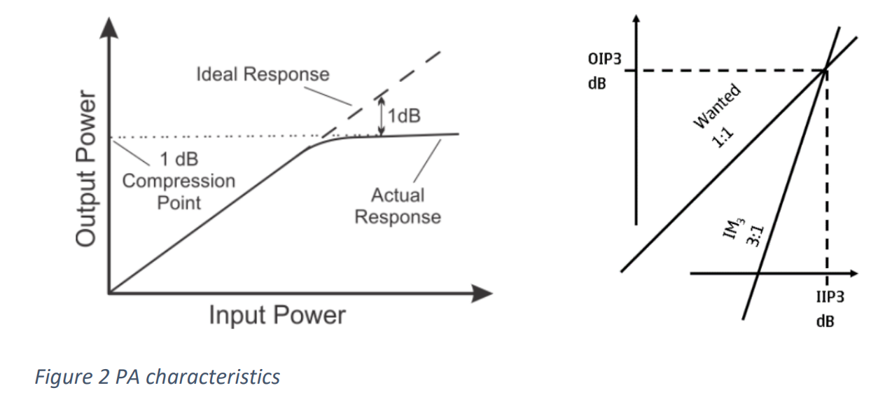

**Question 3:**

We received a requirement to verify two tests: Tx ACLR and Rx IM on a single antenna port Radio unit that can support up to 4 Tx carriers. Product specification for Tx total output power is 46 dBm .

1. propose a measurement bench setup for each test, i.e. block and wiring diagram shows the needed components ( Test Instruments , RF accessories , DUT ) , ensure that your setup is safe for both DUT and Test Instruments.
2. What is the expected measured Tx power per carrier in ACLR test for:
3. one Tx carrier configuration.
4. two Tx carriers configuration.

*For the following exercises provide C# code as an attachment (To be able to compile and run*)

**Question 4:**

The following strings contain hexadecimal values of two points of a curve: gain vs temperature "var1/ext23/gainX1 0X14"

"var1/ext23/gainX2 0X3C"

"var2/ext56/tempY1 0X5F"

"var2/ext56/tempY2 0X2A"

Create a C# program that can:

1. Ask user to input the temperature.

2. Extract the Hexadecimal value from the strings above mentioned, convert them to decimal and calculate the gradient(slope) and Y-intercept point.

3. Print out the values of the gradient, Y-intercept and calculate the gain value given the temperature submitted by the user.

4. What would be the gain if the temperature is 25?

**Question 5:**

Write a program in C# that will give the user the correct SCPI command string if a user wants to control properties of an Analog Signal Generator R&S SMA100B.

a. Set Frequency in Ghz

b. Set output level in dBm with two decimals

c. Enable output

The user should be able to execute the program, choose the action(set Frequency, Set Level or enable output) and give input the value if needed. The program should, in return, print the correct generated SCPI command string with the values given by the user.

Use a separate assembly for the command generator in case the user later wants to add more control commands to the program.